**1. INTRODUCTION**

**1.1 Project Overview**

**1.2 Purpose**

**2. IDEATION PHASE**

**2.1 Problem Statement**

**2.2 Empathy Map Canvas**

**2.3 Brainstorming**

**3. REQUIREMENT ANALYSIS**

**3.1 Customer Journey Map**

**3.2 Solution Requirements**

**3.3 Data Flow Diagram**

**3.4 Technology Stack**

**4. PROJECT DESIGN**

**4.1 Problem-Solution Fit**

**4.2 Proposed Solution**

**4.3 Solution Architecture**

**5. PROJECT PLANNING & SCHEDULING**

**5.1 Project Planning**

**6. FUNCTIONAL AND PERFORMANCE TESTING**

**6.1 Performance Testing**

**7. RESULTS**

**7.1 Output Screenshots**

**8. ADVANTAGES & DISADVANTAGES**

**9. CONCLUSION**

**10. FUTURE SCOPE**

**11. APPENDIX**

**GitHub & Project Demonstration Link**

**1. INTRODUCTION**

**1.1Project Overview**

The Laptop Request Catalog Item project in ServiceNow involves creating a user-friendly and automated form that allows employees to request laptops through the organization’s ServiceNow platform. This item streamlines the hardware request process, ensuring faster approvals, accurate tracking, and better inventory management.

**1.2 Purpose**

The primary goal of this project is to simplify and digitalize the laptop requisition process. By implementing this catalog item, the organization can improve service delivery, reduce manual intervention, and ensure a transparent, traceable workflow for IT hardware provisioning.

1. **IDEATION PHASE**

#### ****Problem Statement****

|  |  |
| --- | --- |
| Date | 16 June 2025 |
| Team ID | LTVIP2025TMID29705 |
| Project Name | laptop request catalog item |
| Maximum Marks | 2 Marks |

Employees face delays and inefficiencies when requesting laptops through manual or email-based systems. Lack of standardized processes leads to confusion, approval delays, and inventory mismanagement. There is a need for a centralized and automated solution to manage laptop requests effectively.

#### ****Empathy Map Canvas****

|  |  |
| --- | --- |
| Date | 16 June 2025 |
| Team ID | LTVIP2025TMID29705 |
| Project Name | laptop request catalog item |
| Maximum Marks | 4 Marks |

|  |  |  |  |  |  |  |  |  |  |  |  |  |  |  |
| --- | --- | --- | --- | --- | --- | --- | --- | --- | --- | --- | --- | --- | --- | --- |
| | **Section** | **Description** | | --- | --- | | **Think & Feel** | Captures the user's internal thoughts, worries, aspirations, and priorities. | | **Hear** | Reflects what the user hears from friends, colleagues, influencers, or media. | | **See** | Describes the user's environment, what they observe, and what competitors offer. | | **Say & Do** | Outlines the user's behavior, public attitude, and how they interact with others. | | **Pain** | Identifies fears, frustrations, and obstacles the user faces. | | **Gain** | Highlights the user's goals, needs, and what success looks like to them. | |

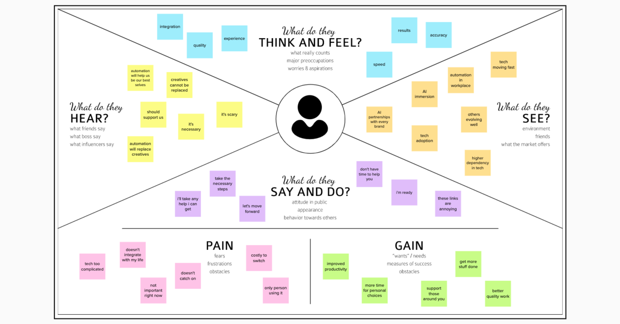

**2.3 Brainstorming**

|  |  |
| --- | --- |
| Date | 16 June 2025 |
| Team ID | LTVIP2025TMID29705 |
| Project Name | laptop request catalog item |
| Maximum Marks | 4 Marks |

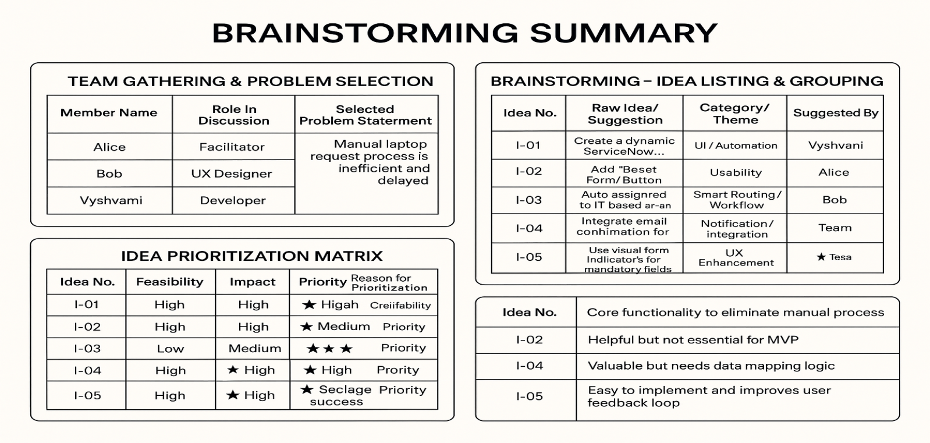

**3. REQUIREMENT ANALYSIS**

**3.1 Customer Journey map**

This visualizes the end-to-end experience of an employee requesting a laptop:

**Awareness**: Employee realizes the need for a laptop.

**Access**: Logs into the ServiceNow portal and navigates to the Hardware Catalog.

**Interaction**: Fills out the dynamic Laptop Request form (selects model, RAM, processor, accessories).

**Approval**: Request is routed to the manager for approval.

**Fulfillment**: Upon approval, a task is assigned to the Hardware team.

**Closure**: Laptop is delivered and the request is marked complete.

**Pain Points Addressed**: Manual delays, lack of clarity, and inconsistent data entry.

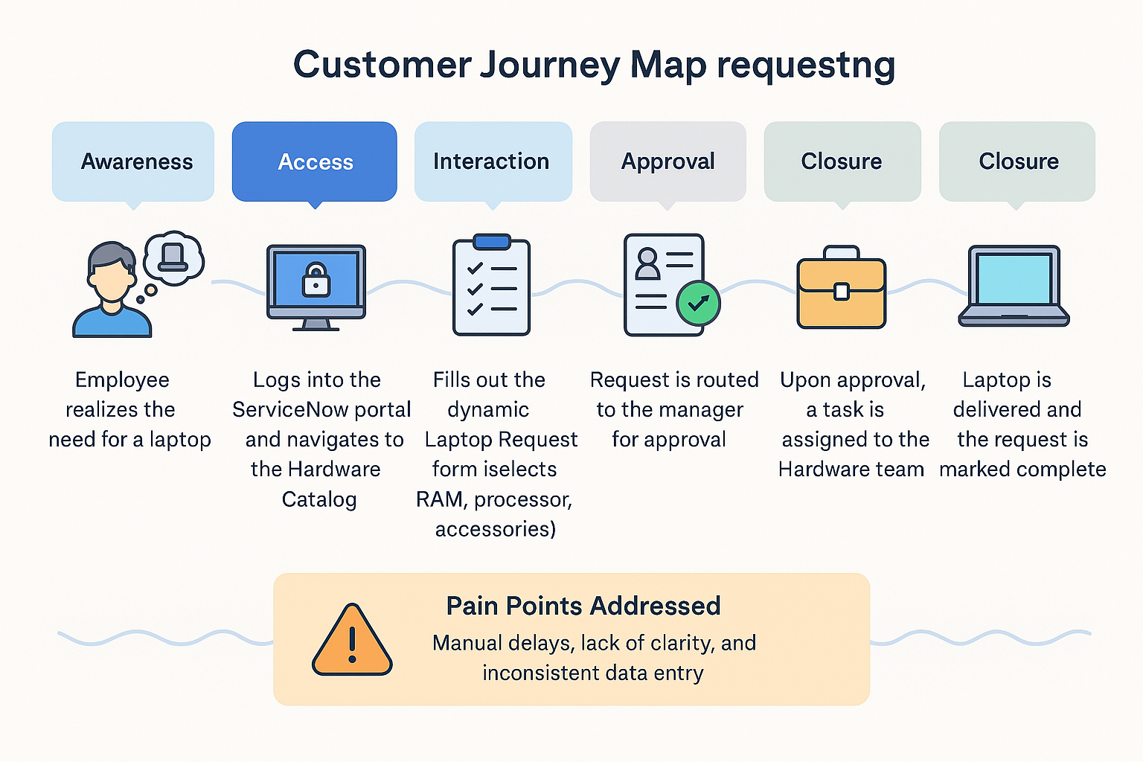

**3.2 Solution Requirement**

|  |  |
| --- | --- |
| Date | 16 June 2025 |
| Team ID | LTVIP2025TMID29705 |
| Project Name | laptop request catalog item |
| Maximum Marks | 4 Marks |

**Functional Requirements:**

Following are the functional requirements of the proposed solution.

| **FR No.** | **Functional Requirement (Epic)** | **Sub Requirement (Story / Sub-Task)** |
| --- | --- | --- |
| FR-1 | User Registration | - Registration through Form <br> - Registration via Gmail <br> - Registration via LinkedIn |
| FR-2 | User Confirmation | - Confirmation via Email <br> - Confirmation via OTP |

**Non-functional Requirements:**

Following are the non-functional requirements of the proposed solution.

|  |  |  |  |  |  |  |  |  |  |  |  |  |  |  |  |  |  |  |  |  |  |
| --- | --- | --- | --- | --- | --- | --- | --- | --- | --- | --- | --- | --- | --- | --- | --- | --- | --- | --- | --- | --- | --- |
| | **NFR No.** | **Non-Functional Requirement** | **Description** | | --- | --- | --- | | NFR-1 | Usability | The system should have an intuitive and user-friendly interface. | | NFR-2 | Security | Implement secure login, data encryption, and access controls. | | NFR-3 | Reliability | The application should operate without failures or data loss. | | NFR-4 | Performance | System should process requests and responses within 2 seconds. | | NFR-5 | Availability | The application should be accessible 99.9% of the time. | | NFR-6 | Scalability | The solution should support increasing users and request volumes efficiently. | |

**3.3 Data Flow Diagram**

|  |  |
| --- | --- |
| Date | 18 June 2025 |
| Team ID | LTVIP2025TMID29705 |
| Project Name | laptop request catalog item |
| Maximum Marks | 4 Marks |

**Level 1 DFD** might include:

**External Entities**: Employee (requestor), Manager, Hardware Team.

**Processes**:

1. Submit Laptop Request
2. Approve Request
3. Fulfill Request

**Data Stores**: Request Table, User Table, Approval Logs

**Data Flows**: Request details, approval status, task assignment, fulfillment status

This diagram shows how data moves from the user to the system and back, ensuring transparency and traceability.

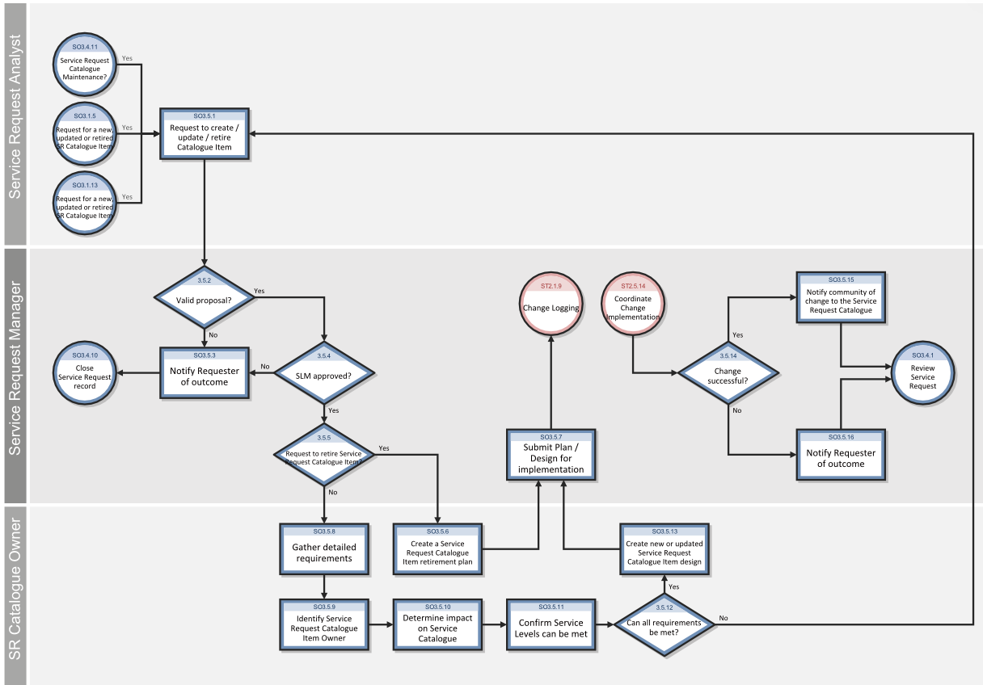

### ****User Stories Related to Data Flow (DFD Perspective)****

#### ****Customer (Mobile User)****

| **User Type** | **Functional Requirement (Epic)** | **User Story Number** | **User Story / Task** | **Acceptance Criteria** | **Priority** | **Release** |
| --- | --- | --- | --- | --- | --- | --- |
| Customer (Mobile user) | Laptop Request Submission | DF-US-1 | As a user, I can submit a laptop request with all required configuration details | Laptop request is captured and forwarded for manager approval | High | Sprint-1 |
| Customer (Mobile user) | Status Tracking | DF-US-2 | As a user, I can track the current status of my laptop request | Status updates are visible in my dashboard | Medium | Sprint-2 |

#### ****Customer (Web User)****

| **User Type** | **Functional Requirement (Epic)** | **User Story Number** | **User Story / Task** | **Acceptance Criteria** | **Priority** | **Release** |
| --- | --- | --- | --- | --- | --- | --- |
| Customer (Web user) | Laptop Request Form Access | DF-US-3 | As a web user, I can access the same dynamic laptop request form as mobile users | Laptop form loads with conditional fields | Medium | Sprint-2 |

#### ****Customer Care Executive****

| **User Type** | **Functional Requirement (Epic)** | **User Story Number** | **User Story / Task** | **Acceptance Criteria** | **Priority** | **Release** |
| --- | --- | --- | --- | --- | --- | --- |
| Customer Care Executive | Request Validation | DF-US-4 | As a CCE, I can verify laptop request details before fulfillment | Validated request moves to hardware dispatch team | High | Sprint-2 |

#### ****Administrator****

| **User Type** | **Functional Requirement (Epic)** | **User Story Number** | **User Story / Task** | **Acceptance Criteria** | **Priority** | **Release** |
| --- | --- | --- | --- | --- | --- | --- |
| Administrator | Audit Logging | DF-US-5 | As an admin, I can view audit logs of request creation and fulfillment flows | All user actions are logged with timestamps for audit reference | High | Sprint-2 |
| Administrator | System Configuration | DF-US-6 | As an admin, I can configure workflows for approval and fulfillment logic | Changes reflect in form behavior and task routing across modules | High | Sprint-3 |

**3.4 Technology Stack**

|  |  |
| --- | --- |
| Date | 18 June 2025 |
| Team ID | LTVIP2025TMID29705 |
| Project Name | laptop request catalog item |
| Maximum Marks | 4 Marks |

### Table-1: Components & Technologies

| **S.No** | **Component** | **Description** | **Technology** |
| --- | --- | --- | --- |
| 1 | User Interface | Web-based interface where users request laptops and view status | HTML, CSS, JavaScript, ServiceNow Catalog UI, GlideForm APIs |
| 2 | Application Logic-1 | Dynamic form logic, field visibility, validations | ServiceNow Client Scripts, UI Policies |
| 3 | Application Logic-2 | Workflow automation and approvals | ServiceNow Flow Designer, Approval Rules, Script Actions |
| 4 | Application Logic-3 | Request routing and task assignment | ServiceNow Business Rules, Catalog Task Workflows |
| 5 | Database | Stores request data, user profiles, tasks | ServiceNow Tables (sc_req_item, sc_task, sys_user) |
| 6 | Cloud Database | Native cloud data storage provided by platform | ServiceNow (built on MySQL backend) |
| 7 | File Storage | Attachments like ID proof or approval docs | ServiceNow Attachments API, Encrypted file storage |
| 8 | External API-1 | Email notifications integration | SMTP / Outlook API |
| 9 | External API-2 | Optional future integration (e.g., asset validation via vendor APIs) | REST APIs / MID Server scripts |
| 10 | Machine Learning Model | Optional future enhancement (e.g., predictive asset assignment) | Not currently used, possible integration via AI Search |
| 11 | Infrastructure (Server/Cloud) | Cloud-based deployment of ServiceNow platform | Hosted on ServiceNow Cloud (SaaS); no local setup needed |

### Table-2: Application Characteristics

| **S.No** | **Characteristics** | **Description** | **Technology / Notes** |
| --- | --- | --- | --- |
| 1 | Open-Source Frameworks | Scripted APIs and web standards used in UI logic | ECMAScript, Bootstrap (within ServiceNow components) |
| 2 | Security Implementations | Role-based access, data encryption, audit logging | ACLs, SHA-256 Hashing, RBAC, ServiceNow Security Policies |
| 3 | Scalable Architecture | Modular service catalog structure, reusable workflows | 3-tier architecture using ServiceNow platform layers |
| 4 | Availability | Platform maintained on enterprise-grade infrastructure | 99.9% uptime via ServiceNow SaaS with clustering and failover |
| 5 | Performance | Caching used in workflows, indexed database queries, asynchronous tasks | GlideRecord optimizations, ServiceNow Performance Analytics |

1. **PROJECT DESIGN**
   1. **Problem Solution Fit**

|  |  |
| --- | --- |
| Date | 19 June 2025 |
| Team ID | LTVIP2025TMID29705 |
| Project Name | laptop request catalog item |
| Maximum Marks | 4 Marks |

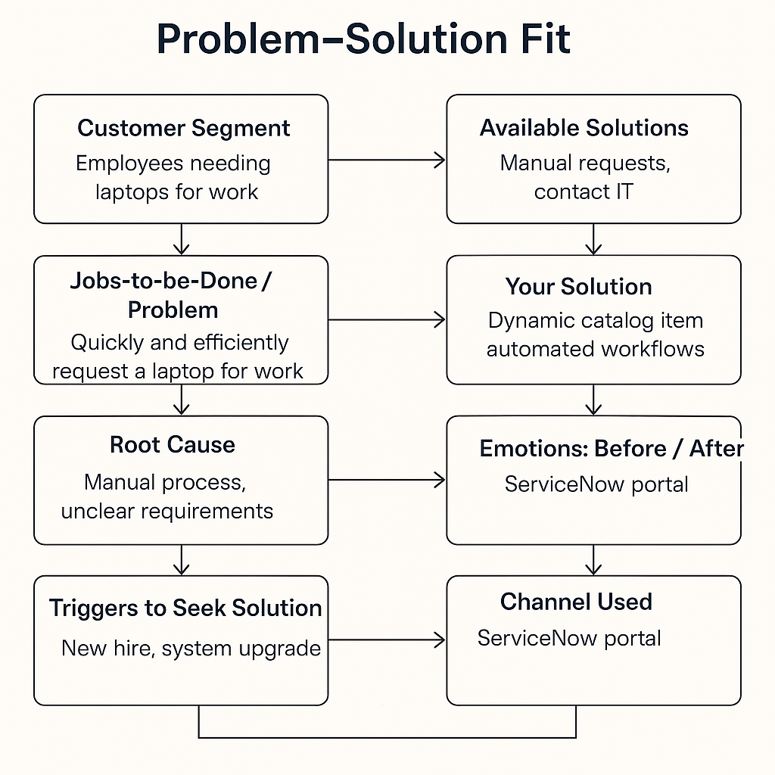

| **Section** | **Insight** |
| --- | --- |
| **Customer Segment (CS)** | Defines your target users – for example, employees needing laptops for work. |
| **Customer Constraints (CC)** | Barriers like lack of time, unfamiliar forms, or manual delays. |
| **Available Solutions (AS)** | Existing manual request methods or contacting IT directly. |
| **Jobs-to-be-Done / Problems (J&P)** | The core need: quickly and efficiently request a laptop for work. |
| **Root Cause (RC)** | Manual process, unclear requirements, lack of self-service tools. |
| **Customer Behavior (BE)** | Users ask peers or IT manually; unaware of digital request options. |
| **Triggers (TR)** | New hire onboarding, system upgrades, or broken devices. |
| **Your Solution (SL)** | A dynamic ServiceNow catalog item with automated workflows and form validation. |
| **Channels (CH)** | ServiceNow portal, internal emails, onboarding documentation. |
| **Emotions: Before / After (EM)** | Before: Frustrated, delayed. <br>After: Confident, satisfied, empowered. |

* 1. **Proposed Solution**

|  |  |  |  |  |  |  |  |  |  |  |  |  |  |  |  |  |  |  |  |  |  |
| --- | --- | --- | --- | --- | --- | --- | --- | --- | --- | --- | --- | --- | --- | --- | --- | --- | --- | --- | --- | --- | --- |
| | **S.No.** | **Parameter** | **Description** | | --- | --- | --- | | 1 | **Problem Statement** | Employees currently face delays and inconsistencies due to the manual laptop request process, lacking dynamic guidance, validation, and tracking. | | 2 | **Idea / Solution Description** | Design and deploy a dynamic ServiceNow Catalog Item for Laptop Requests with conditional fields, validation rules, workflow automation, and audit trail. | | 3 | **Novelty / Uniqueness** | Integrates dynamic form logic, real-time validation, reset functionality, approval workflows, and task automation — all within a single self-service portal. | | 4 | **Social Impact / Customer Satisfaction** | Reduces manual workload, minimizes errors, and improves turnaround time, leading to higher employee satisfaction and streamlined IT operations. | | 5 | **Business Model (Revenue Model)** | As an internal organizational tool, the model supports operational efficiency. Optionally, the solution can be packaged as a module for enterprise clients. | | 6 | **Scalability of the Solution** | The catalog item can be extended to include other hardware or software requests, additional workflows, and integrations with asset management systems. | |

* 1. **Solution Architecture**

|  |  |
| --- | --- |
| Date | 19 June 2025 |
| Team ID | LTVIP2025TMID29705 |
| Project Name | laptop request catalog item |
| Maximum Marks | 4 Marks |

| **Aspect** | **Description** |
| --- | --- |
| **Objective** | Bridge the gap between business needs (e.g., laptop requests) and technical implementation using ServiceNow. |
| **Key Goals** | Identify the best-fit tech solution, define system behavior, outline development phases, and provide implementation specs. |
| **Core Components** | - **User Interface**: ServiceNow Catalog Item<br>- **Business Logic**: Client Scripts, UI Policies, Flow Designer<br>- **Data Layer**: ServiceNow Tables (sc_req_item, sc_task)<br>- **Integration**: Email Notifications, Approval Workflows<br>- **Governance**: Audit Logs, Update Sets |
| **Stakeholders** | Employees, Managers, IT Fulfillment Team, Admins |
| **Development Phases** | 1. Requirement Gathering<br>2. Catalog Item Design<br>3. Workflow Automation<br>4. Testing & Deployment |
| **Delivery Specs** | Defined via update sets, version control, and role-based access policies |

**5. PROJECT PLANNING & SCHEDULING**

**5.1 Project Planning**

| **Element** | **Description** |
| --- | --- |
| **Project Scope** | Develop a ServiceNow Catalog Item for laptop requests with dynamic fields, approval workflows, and audit tracking. |
| **Project Goals** | - Streamline laptop request process<br>- Improve user experience<br>- Ensure governance and traceability |
| **Stakeholders** | Employees, Managers, IT Fulfillment Team, ServiceNow Admins |
| **Project Phases** | 1. Requirement Gathering<br>2. Design & Prototyping<br>3. Development<br>4. Testing<br>5. Deployment<br>6. Feedback & Optimization |
| **Deliverables** | - Dynamic Catalog Item<br>- Approval Workflow<br>- Task Assignment Logic<br>- Audit Logs<br>- User Documentation |
| **Tools & Technologies** | ServiceNow, Flow Designer, Client Scripts, UI Policies, Update Sets |
| **Team Roles** | - Developer: Form logic, scripting<br>- Admin: Workflow & access control<br>- QA: Testing & validation<br>- Project Lead: Coordination & reporting |
| **Timeline** | Estimated 4–6 weeks (adjustable based on sprint planning and feedback loops) |

**6. FUNCTIONAL AND PERFORMANCE TESTING**

**6.1 Performance Testing**

|  |  |
| --- | --- |
| Date | 21 June 2025 |
| Team ID | LTVIP2025TMID29705 |
| Project Name | laptop request catalog item |
| Maximum Marks | 4 Marks |

|  |  |  |  |  |  |  |  |  |  |  |  |  |  |  |  |  |  |  |  |  |  |  |  |  |  |  |  |  |  |  |
| --- | --- | --- | --- | --- | --- | --- | --- | --- | --- | --- | --- | --- | --- | --- | --- | --- | --- | --- | --- | --- | --- | --- | --- | --- | --- | --- | --- | --- | --- | --- |
| | **Test Type** | **Purpose** | | --- | --- | | **Load Testing** | Assess system behavior under normal and peak user loads. | | **Stress Testing** | Determine system limits by pushing beyond expected load. | | **Spike Testing** | Evaluate how the system handles sudden surges in traffic. | | **Soak Testing** | Check for memory leaks or degradation over extended usage periods. |  📊 Performance Metrics  | **Metric** | **Description** | | --- | --- | | **Response Time** | Time taken to load the catalog form or submit a request. | | **Throughput** | Number of requests processed per second/minute. | | **Error Rate** | Percentage of failed requests under load. | | **Resource Usage** | CPU, memory, and database utilization during test cycles. |  🛠️ Tools & Environment  | **Component** | **Details** | | --- | --- | | **Test Tool** | JMeter or LoadRunner (for simulating user load) | | **Monitoring Tools** | ServiceNow Performance Analytics, built-in logs | | **Test Environment** | Pre-production ServiceNow instance with production-like configuration | | **Test Data** | Simulated user accounts, request payloads, and approval workflows | |

1. **RESULTS** 
   1. **Output Screenshots**

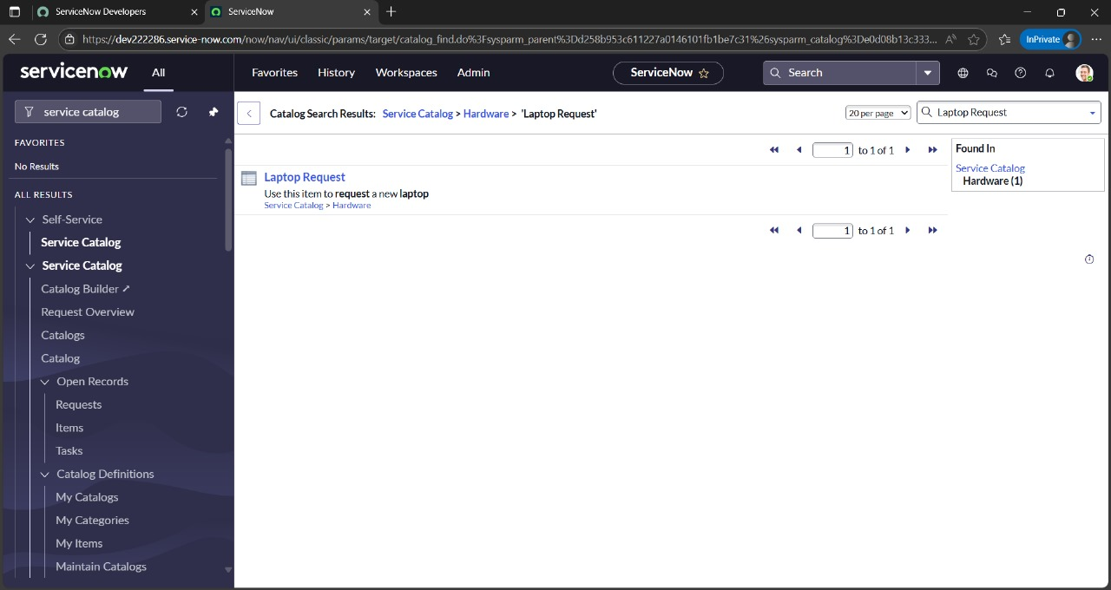

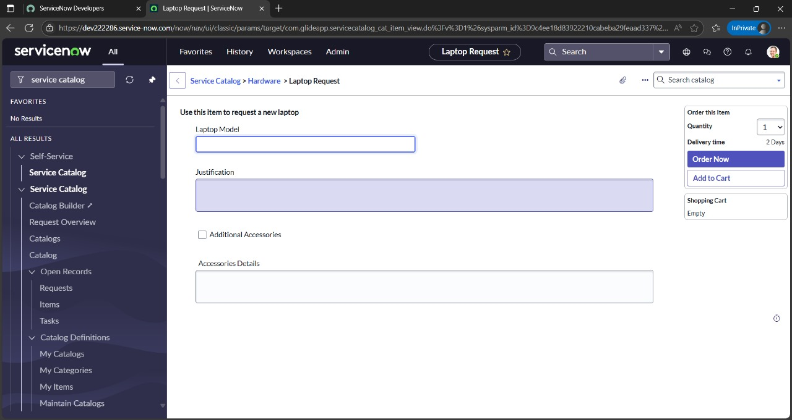

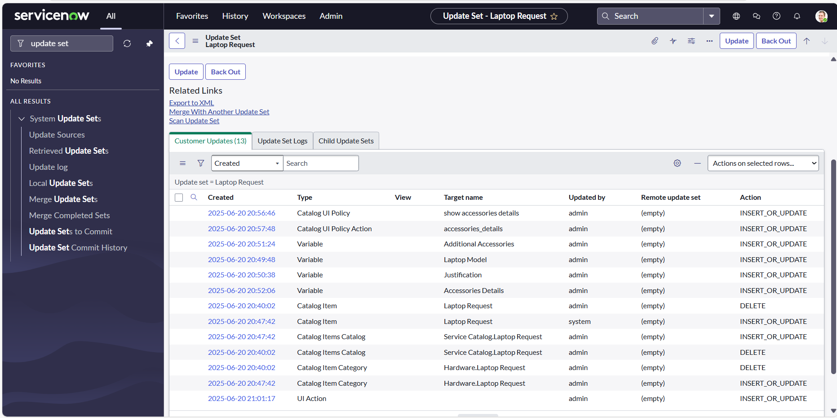

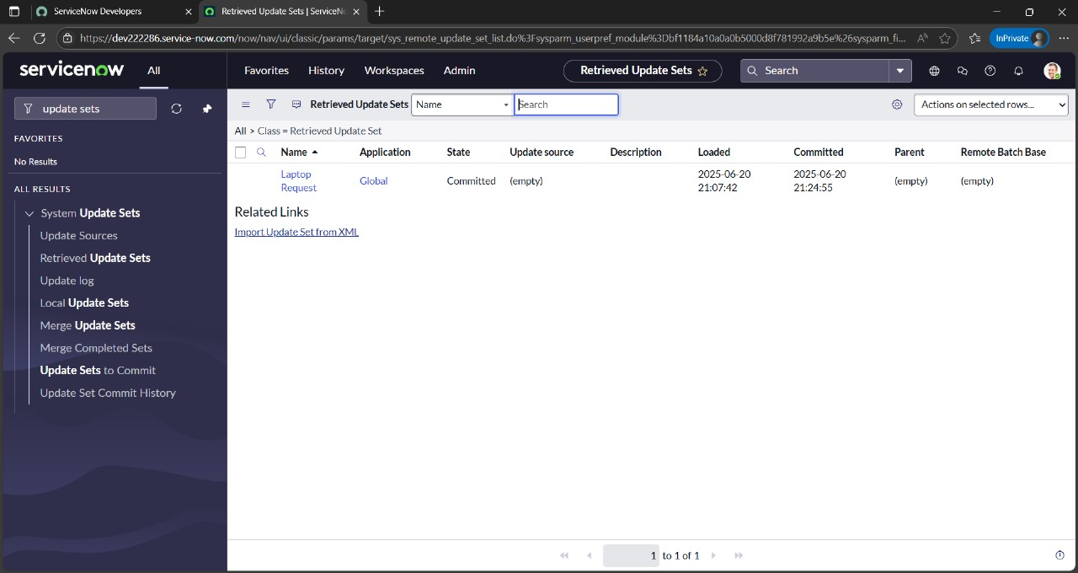

1. **ADVANTAGES & DISADVANTAGES**

|  |  |  |  |  |  |  |  |  |  |  |  |  |  |  |  |
| --- | --- | --- | --- | --- | --- | --- | --- | --- | --- | --- | --- | --- | --- | --- | --- |
| | **Aspect** | **Advantages** | **Disadvantages** | | --- | --- | --- | | **Efficiency** | Automates the laptop request process, reducing manual errors and turnaround time. | Initial setup may require significant configuration and understanding of ServiceNow. | | **User Experience** | Dynamic forms and guided UI improve clarity and reduce form abandonment. | Some users may still need training for new form behavior or self-service navigation. | | **Governance** | Tracks all requests and changes for audit and compliance purposes. | Workflow complexity may increase as more features or conditions are added. | | **Integration** | Easily integrates with email, notifications, and task routing systems. | Dependency on platform-specific capabilities may limit external customization. | |

1. **CONCLUSION**

The proposed solution transforms a traditionally manual and error-prone process into an intelligent, user-friendly workflow using ServiceNow. By combining dynamic forms, automated approvals, role-based access, and backend tracking, it not only streamlines laptop provisioning but also improves stakeholder satisfaction. The project demonstrates how thoughtful digital transformation can enhance internal IT services while aligning with governance and usability goals.

1. **FUTURE SCOPE**

· **Multi-Device Support**: Extend the catalog to include mobile phones, monitors, or accessories.

· **Asset Inventory Integration**: Auto-check availability and assign pre-registered asset tags.

· **Analytics Dashboard**: Generate real-time reports on request trends and SLA metrics.

· **AI Recommendations**: Suggest devices based on user role or department history.

· **Multi-language Support**: Enhance accessibility for a diverse global workforce.

· **Self-Help Chatbot**: Guide users through the request process via a conversational assistant (could even use NLP concepts you're exploring!).

1. **APPENDIX**

**GitHub :-** [NagaVyshnaviJ/Laptop-Request-Catalog-Item-ServiceNow-](https://github.com/NagaVyshnaviJ/Laptop-Request-Catalog-Item-ServiceNow-)

**Project Demonstration Link**  :- https://drive.google.com/file/d/1FdbMFRkEy7hCKNnCQXhjOJYNOQDvYuXt/view?usp=sharing